POM (Asahi Kasei)

Engineering plastics with a superior, high-level balance of mechanical and slide characteristics, widely used in the production of electrical and electronic, automotive, and industrial parts and components.

[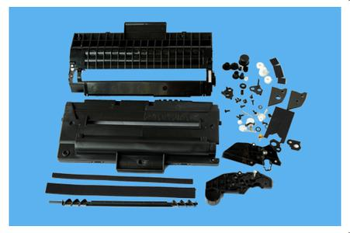](http://image.baidu.com/i?ct=503316480&z=&tn=baiduimagedetail&ipn=d&word=%E6%89%93%E5%8D%B0%E6%9C%BA%E5%86%85%E4%BB%B6&step_word=&ie=utf-8&in=280&cl=2&lm=-1&st=&pn=1&rn=1&di=58436013131&ln=2000&fr=&&fmq=1392359917064_R&ic=&s=&se=&sme=0&tab=&width=&height=&face=&is=&istype=&ist=&jit=&objurl=http%3A%2F%2Fa.img.youboy.com%2FCOImg%2F2008%2F8%2F21%2Fg748426.jpg)